

SRI LANKA INSTITUTE OF INFORMATION

TECHNOLOGY

Enterprise Standards and Best Practices for IT Infrastructure

**4th Year 2nd Semester 2016**

**ISO 27001 certification**

**Name: T.I.Cassim**

**SLIIT ID: IT12051380**

**Practical Session: WE Tuesday**

**Practical Number : Lab 05**

**Date of submission : 2016/08/29**

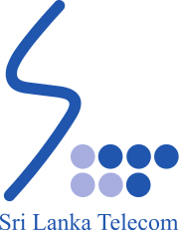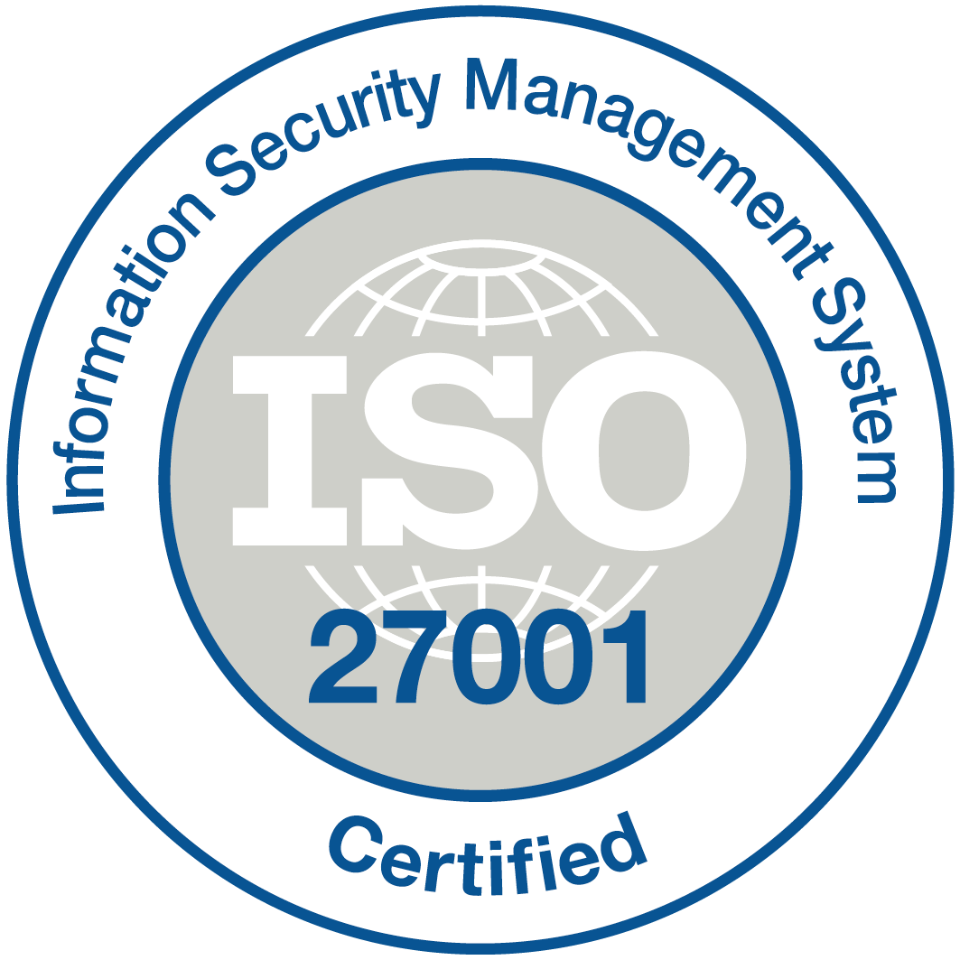

Srilanka Telecom PLC (SLT) is a telecommunication services provider in srilanka and one of the country’s largest companies with an annual turnover in excess of 40 billion rupees. The Company provides a domestic and corporate service which includes fixed and wireless telephony, Internet access and IT services to domestic, public sector and business sector customers.

Srilanka telecom has a history of over 150 years, having started its operations in 1858 with the establishment of the first Telegraphic Circuit between Galle and Colombo. In the same year it established its first international Telegraph Communication between then called Ceylon, and India. Since then, Sri Lanka Telecom has passed several milestones, including: in 1991 Sri Lanka Telecom became a Corporation and in 1997 the Company was privatized with the collaboration of Nippon Telegraph and Telephone Corporation (NTT) and listed in the Colombo Stock Exchange's Milanka Price Index.

In 2008, NTT sold its stake in SLT to Global Telecommunications Holdings N.V. of Netherlands, which currently owns 44.98% stake in Sri Lanka Telecom (SLT) whilst 50.50% is owned by the Government of Sri Lanka and the balance shares remain with the general public.

**Srilanka Telecom and ISO 27001**

ISO 27001 is a specification for an information security management system (ISMS). An ISMS is a framework of policies and procedures that includes all legal, physical and technical controls involved in an organization’s information risk management processes.

According to its documentation, ISO 27001 was developed to "provide a model for establishing, implementing, operating, monitoring, reviewing, maintaining and improving an information security management system."

ISO 27001 is the most stringent certification for information security controls, guarantees that ample information security controls and other forms of risk management and are in place to enable an organization to assess its risk and implement appropriate controls to preserve confidentiality, integrity and availability of information assets.

Sri Lanka Telecom is the first Company incorporated in Sri Lanka to achieve this security standard as well as to be listed in the prestigious Information Security Management System (ISMS) Registry since 2006.

This accreditation verifies that the ISO 27001:2005 information security standard is an integral component of Core IT & Network Operations within SLT and ensures compliance with ISMS policies, procedures and the institutionalization of ISO standard practices across the entire organization.

**why iso27001 need**

The certification spans across the company’s IT Operations including Systems Administration, Billing, Operational Support Systems, System Development, Network & End User Support, Network Operations such as SLT NOC and island-wide broadband network operations including IP-VPN/MPLS/Data services & Internet Service Provider (SLTNET) Broadband Services, Internet Data Centre (SLT iDC), Network Management & Network Security, Disaster Recovery Centre and core support services such as Power & AC operations and physical security management.

**Benefits of having ISO 27001 for Srilanka Telecom**

* Can improve business and processes.
* Provides reassurance to clients that their information is secure
* Demonstrates credibility and trust
* Supports compliance with relevant laws and regulations
* Reduces likelihood of facing prosecution and fines
* Can help to gain status as a preferred supplier
* Improves your ability to recover their operations and continue
* business as usual
* Get a competitive advantage
* Improved information security awareness
* Reduces staff-related security breaches

**Weakness of having ISO 27001 for Srilanka Telecom**

1. Security management system of companies specification

* the certification body simply declare that they have successfully performed but SLT does not publish or released their design and height of certificate

1. Scoping

* Logo and branding associated with certification does not identify scope. A clear statement of scope, identifying precisely what business function is included most published.

1. Industry take up and understanding

* Management of SLT is change over a year. So every year they cannot continue the certificate. Because of misunderstanding of what the standard is and perceived high project cost
* Misunderstanding – ISO 27001 still seen wrongly as technical security standard.
* Cost - ISO 27001 still seen wrongly as expensive standards to adhere too. Registering and maintaining ISO 27001 can cost as organization as more than 12000 rupees per year.

1. Business to business focused

* ISO 27001 can give obviously business to business relationships a competitive advantage, but influence business to customer relationships. Consumers see through logo. It’s just like a marketing gimmick.